Name____________________________ Class______________________ Date______________________

States of Matter
- What are three common states of matter?
a._____________________________ b.________________________ c.____________________________
- Is the following sentence true or false? The fact that a copper wire can be bent shows that some solids do not have a definite shape. ______________
- Circle the letter of each phrase that describes how particles at the atomic level are arranged within most solids.

- Randomly arranged
- packed close together
- arranged in a regular pattern
- spaced far apart

- Is the following sentence true or false? A liquid takes the shape of its container. ______________
- What is the state of matter in which a material has neither a definite shape nor a definite volume? ___________________________________________________________________________________
- Compare and contrast the arrangement of particles at the atomic level for a liquid and a solid. _______________________________________________________________________________________________________________________________________________________________________
- What determines the shape and volume of a gas? ______________________________________________________________________________________________________________________________________________________________________________
- Complete the table about states of matter.
States of Matter
State | Shape | Volume
 | Definite
Liquid
 |  | Not definite
- Describe kinetic energy. ________________________________________________________________________________________________________________________________________________________________________
- Circle the letter of the phrase that describes all particles of matter in the kinetic theory of matter.

- Randomly arranged
- Constant temperature
- In constant motion
- Orderly arrangement

- Why can scientists ignore the forces of attraction among particles in a gas under ordinary conditions?
________________________________________________________________________________________________________________________________________________________________________
- Do forces of attraction have a stronger effect on the behavior of the particles in a gas or in a liquid? ____________________________________________________________________________________

- Circle the letter of each factor that affects the behavior of liquids.

- Fixed location of particles
- Constant motion of particles
- Orderly arrangement of particles
- Forces of attraction among particles

- What is a phase change? ______________________________________________________________
Match each term with the letter of the phase-change description that best describes it.

Term
- Freezing _______________
- Sublimation _____________
- Condensation ____________
- Melting _________________
- Deposition ______________
- Vaporization _____________
Phase-Change
- Solid to gas
- Liquid to gas
- Gas to solid
- Liquid to solid
- Gas to liquid
- Solid to liquid

- What happens to the temperature of a substance during a phase change? ____________________________________________________________________________________
- Is the following sentence true or false? The temperature at which a substance freezes is lower than the temperature at which it melts. __________________
- Circle the letter that describes the behavior of a substance during a phase change.
- Neither absorbs nor releases energy
- Always absorbs energy
- Always releases energy
- Either absorbs or releases energy
- A substance absorbs energy from its surroundings during a(n) ___________________________ change.
- The energy absorbed by one gram of ice as it melts is known as the ________________________ for water.
- As water freezes, it releases heat to its surroundings. Freezing is an example of a (n) _______________ change.
- When liquid water freezes, the average kinetic energy of its molecules _________________________, and the arrangement of the molecules becomes more orderly.
- Vaporization is the phase change in which a substance changes from a (n) ______________________ into a (n) _____________________________________.
- The energy absorbed by one gram of water as it changes from its liquid phase into water vapor is known as the ___________________________________ for water.
- Is the following sentence true or false? When water vapor collects above the liquid in a closed container, the pressure caused by the collisions of this vapor and the walls of the container is called vapor pressure. _______________
- Compare and contrast the processes of evaporation and boiling by completing the table below.
Evaporation and Boiling
Process | Phase Change | Where it Occurs | Temperature
Evaporation
Boiling
- Is the following sentence true or false? A gas absorbs energy as it changes into a liquid. ____________
- Dry ice can change directly from a solid to a gas without forming a liquid first. This process is an example of __________________________________________________________.
- What is deposition? ________________________________________________________________________________________________________________________________________________________________________

PHASE DIAGRAM OF COMPOUND X
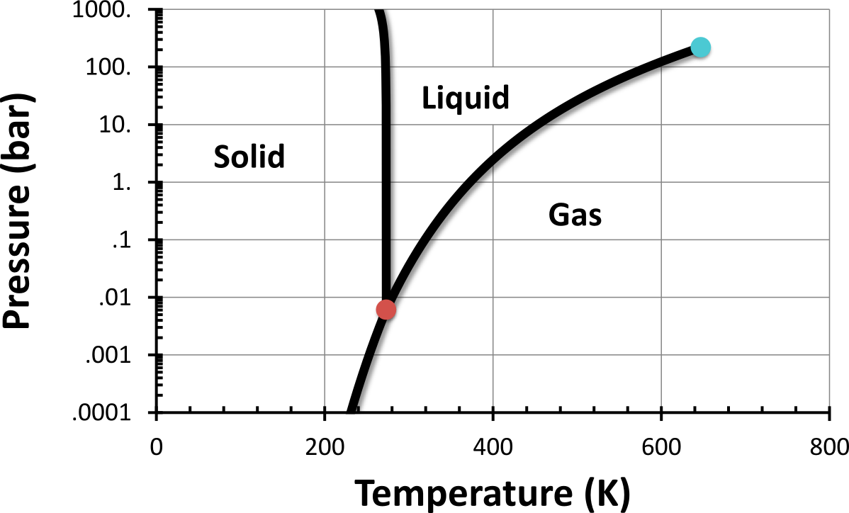
- Label in the graph above the following: critical point, triple point, the six phase changes, critical pressure, and critical temperature.

- If you were to have a bottle containing compound X in your closet, what phase would it most likely be in? (Hint: Assume room temperature is 22°C and pressure is 1 bar) ________________________________________________________________________________________________________________________________________________________________________
- At what temperature and pressure will all three phases coexist? ________________________________________________________________________________________________________________________________________________________________________
- If I have a bottle of compound X at a pressure of 50 bar and temperature of 200 K, what will happen if I raise the temperature to 600 K? ________________________________________________________________________________________________________________________________________________________________________
- If I wanted to, could I drink compound X? Why or why not? ________________________________________________________________________________________________________________________________________________________________________

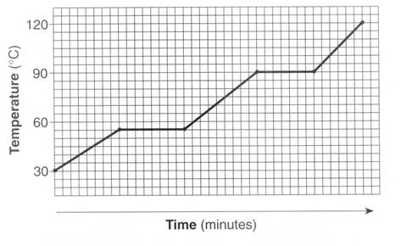
V
IV
III
II
I
- In what part of the curve would substance X have a definite shape and definite volume? __________
- In what part of the curve would substance X have a definite volume but no definite shape? _________
- In what part of the curve would substance X have no definite shape or volume? ______________
- What part of the curve represents a mixed solid/liquid phase of substance X? ________________
- What part of the curve represents a mixed liquid/vapor phase of substance X? _________________
- What is the melting temperature of substance X?___________________________
- What is the boiling temperature of substance X? ________________________
- What part of the curve would have the largest kinetic energy? ________________________
- What part of the curve would have the lowest kinetic energy? __________________________
- In what part of the curve would the molecules of the substance be the farthest apart? ____________
- In what part of the curve would the molecules of the substance be closest together? ______________

