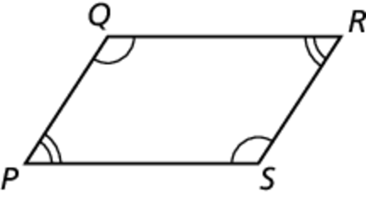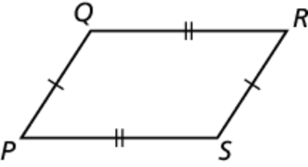Name Date

Notetaking with Vocabulary

For use after Lesson 7.2

7.2

In your own words, write the meaning of each vocabulary term.

parallelogram – quadrilateral with both pairs of opposite sides parallel

Theorems

Theorem 7.3 Parallelogram Opposite Sides Theorem

If a quadrilateral is a parallelogram, then   
its opposite sides are congruent.

If *PQRS* is a parallelogram, then 

and 

Notes:

Theorem 7.4 Parallelogram Opposite Angles Theorem

If a quadrilateral is a parallelogram, then

its opposite angles are congruent.

If *PQRS* is a parallelogram, then 

and

Notes:

Name Date

7.2

Notetaking with Vocabulary **(continued)**

Theorem 7.5 Parallelogram Consecutive Angles Theorem

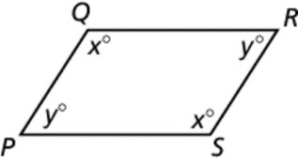If a quadrilateral is a parallelogram, then its

consecutive angles are supplementary.

If *PQRS* is a parallelogram, then 

Notes:

Theorem 7.6 Parallelogram Diagonals Theorem

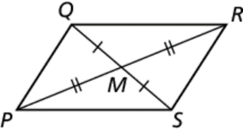If a quadrilateral is a parallelogram, then its

diagonals bisect each other.

If *PQRS* is a parallelogram, then  and 

Notes:

Name Date

7.2

Notetaking with Vocabulary **(continued)**

Extra Practice

In Exercises 1–3, find the value of each variable in the parallelogram.

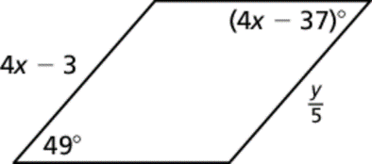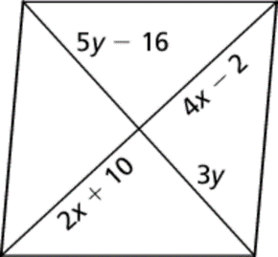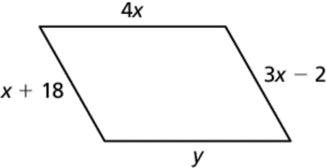 1. 2. 3.

In Exercises 4–11, find the indicated measure in Explain your reasoning.

4. *PO*

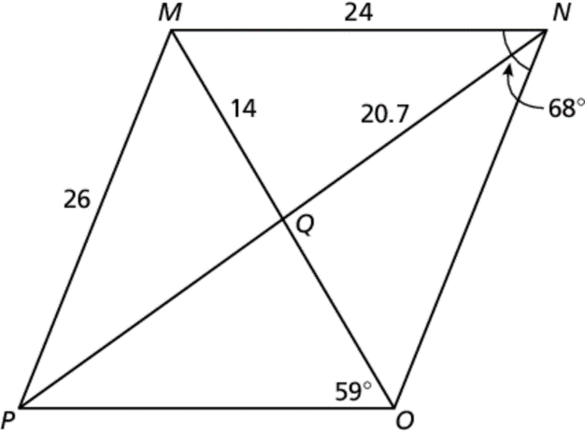

5. *OQ*

6. *NO*

7. *PQ*

8. 

9. 

10. 

11. 