Name Date

Notetaking with Vocabulary

For use after Lesson 5.7

5.7

In your own words, write the meaning of each vocabulary term.

congruent figures – geometric figures that have the same size and shape

corresponding parts – pair of sides or angles that have the same relative position in two congruent figures

construction – geometric drawing that uses a set of tools, usually a compass and a straightedge

Notes:

Name Date

5.7

Notetaking with Vocabulary **(continued)**

Extra Practice

In Exercises 1–3, explain how to prove that the statement is true.

1. 

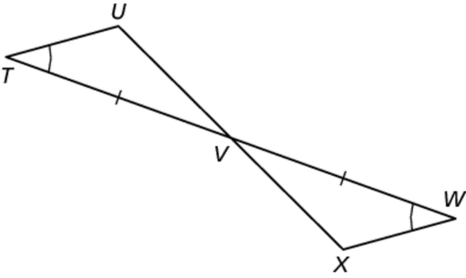

2. 

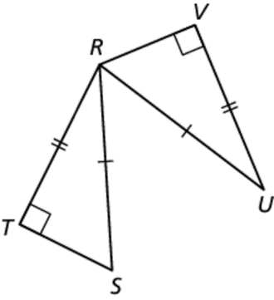

3. 

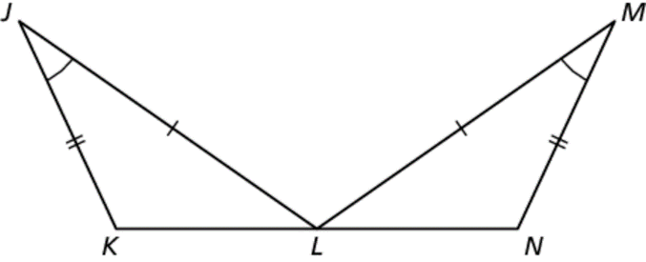

In Exercises 4 and 5, write a plan to prove that 

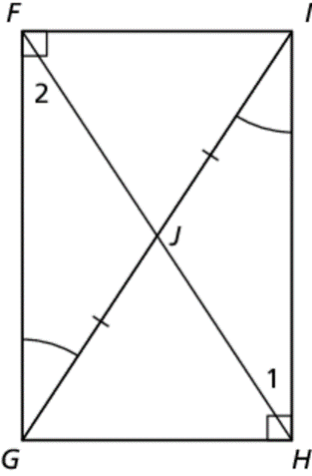 4.

Name Date

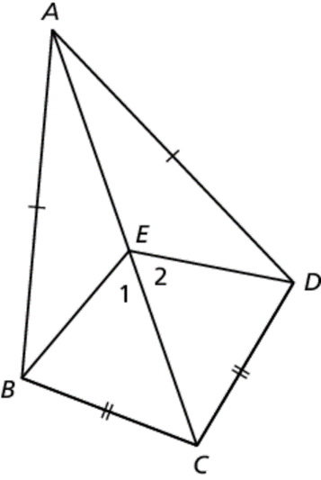 5.

5.7

Notetaking with Vocabulary **(continued)**

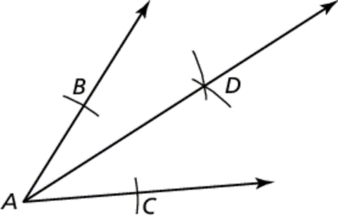 6. Write a proof to verify that the construction is valid.

Ray bisects an angle

**Plan for Proof** Show that  by the SSS   
Congruence Theorem (Thm. 5.8). Use corresponding parts of   
congruent triangles to show that 

|  |  |
| --- | --- |
| STATEMENTS | REASONS |
|  | 1. Given 2. Reflexive property of congruence 3. SSS congruence theorem 4. Corresponding parts of congruent triangles are congruent |
|  |  |
|  |  |
|  |  |