Name Date

Notetaking with Vocabulary

For use after Lesson 5.6

5.6

In your own words, write the meaning of each vocabulary term.

congruent figures – geometric figures that have the same size and shape

rigid motion – transformation that preserves length and angle measure

Theorems

Theorem 5.10 Angle-Side-Angle (ASA) Congruence Theorem

If two angles and the included side of one triangle are congruent 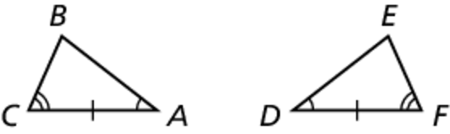  
to two angles and the included side of a second triangle, then the   
two triangles are congruent.

If  and  then   


Notes:

Theorem 5.11 Angle-Angle-Side (AAS) Congruence Theorem

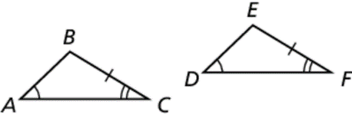If two angles and a non-included side of one triangle are   
congruent to two angles and the corresponding non-included side   
of a second triangle, then the two triangles are congruent.

If  and  then  


Notes:

Name Date

5.6

Notetaking with Vocabulary **(continued)**

Extra Practice

In Exercises 1–4, decide whether enough information is given to prove that the triangles are congruent. If so, state the theorem you would use.

1.  2. 

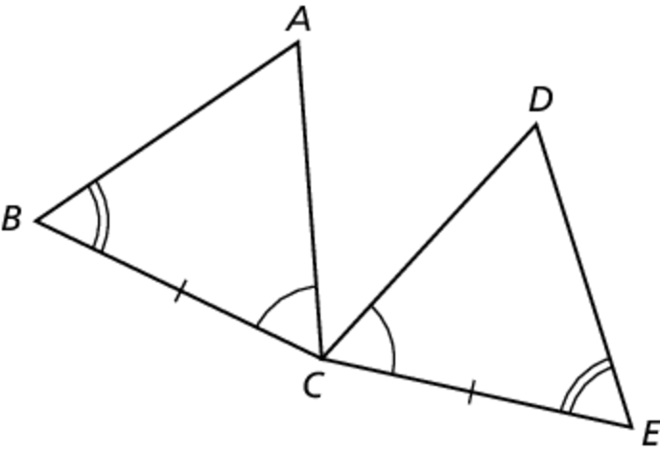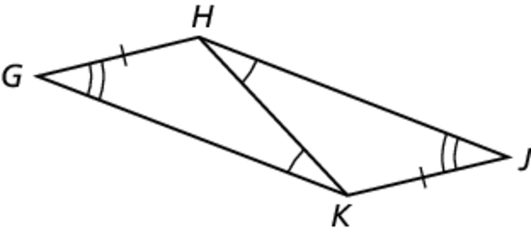

3.  4. 

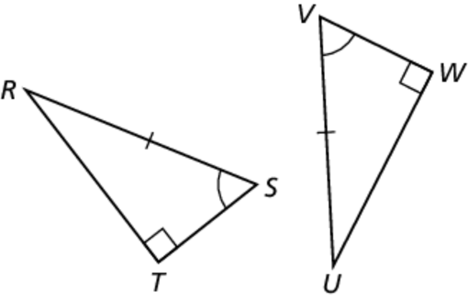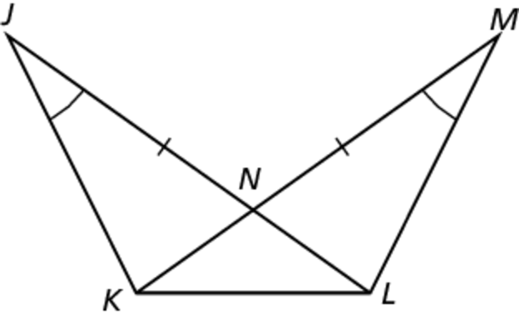

In Exercises 5 and 6, decide whether you can use the given information to prove that   
 Explain your reasoning.

5. 

6. 

Name Date

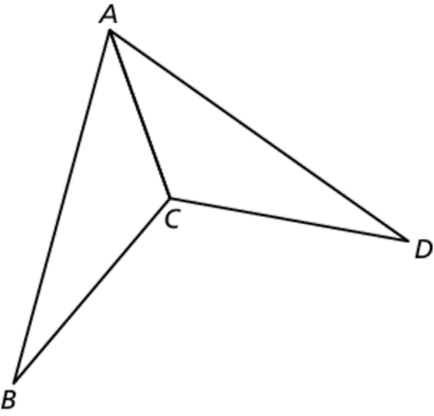 7. Prove that the triangles are congruent using the ASA   
Congruence Theorem (Theorem 5.10).

5.6

Notetaking with Vocabulary **(continued)**

**Given**  bisects  and 

**Prove** 

|  |  |
| --- | --- |
| STATEMENTS | REASONS |
|  | 1. Given |
|  | 1. Definition of angle bisector |
|  | 1. Reflexive property of congruence |
|  |  |
|  | 1. ASA congruence theorem |

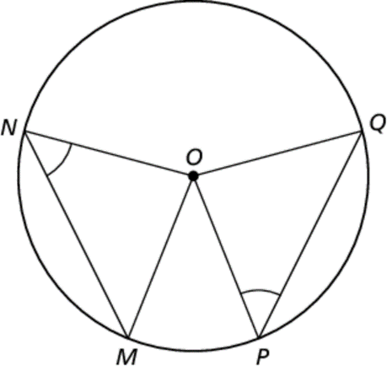 8. Prove that the triangles are congruent using the AAS   
Congruence Theorem (Theorem 5.11).

**Given** *O* is the center of the circle and 

**Prove** 

|  |  |
| --- | --- |
| STATEMENTS | REASONS |
|  | 1. Given 2. Radius on the same circle is congruent 3. Base angles theorem |
|  | 1. AAS congruence theorem |
|  |  |
|  |  |