Name Date

Notetaking with Vocabulary

For use after Lesson 5.5

5.5

In your own words, write the meaning of each vocabulary term.

legs – sides adjacent to the right angle in a right triangle

hypotenuse – side opposite the right angle in a right triangle

Theorems

Theorem 5.8 Side-Side-Side (SSS) Congruence Theorem

If three sides of one triangle are congruent to three sides of a 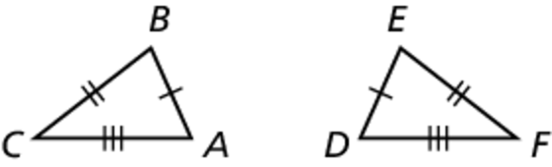  
second triangle, then the two triangles are congruent.

If  then  


Notes:

Theorem 5.9 Hypotenuse-Leg (HL) Congruence Theorem

If the hypotenuse and a leg of a right triangle are congruent to   
the 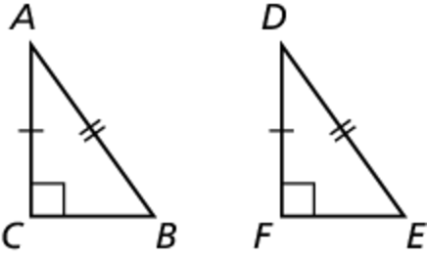hypotenuse and a leg of a second right triangle, then the   
two triangles are congruent.

If  and  then   


Notes:

Name Date

5.5

Notetaking with Vocabulary **(continued)**

**Extra Practice**

In Exercises 1–4, decide whether the congruence statement is true. Explain your reasoning.

1.  2. 

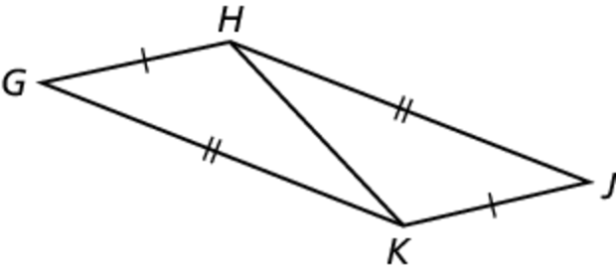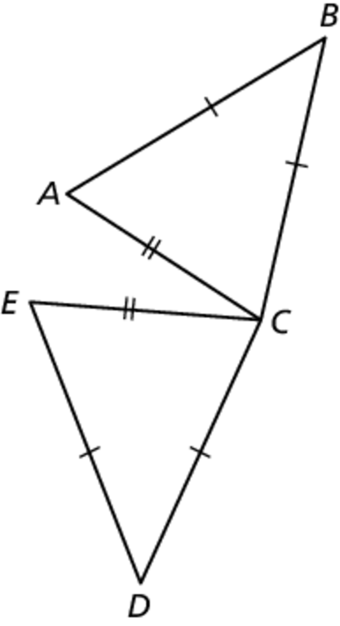

3.  4. 

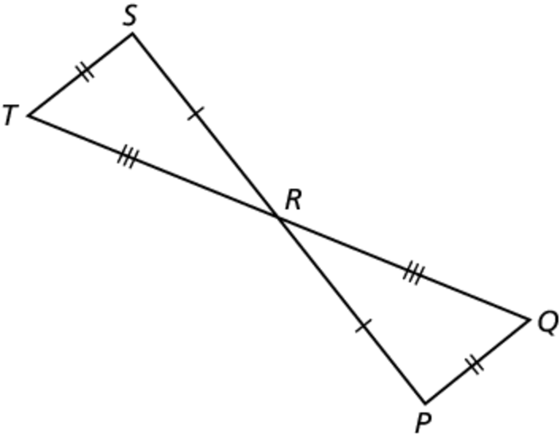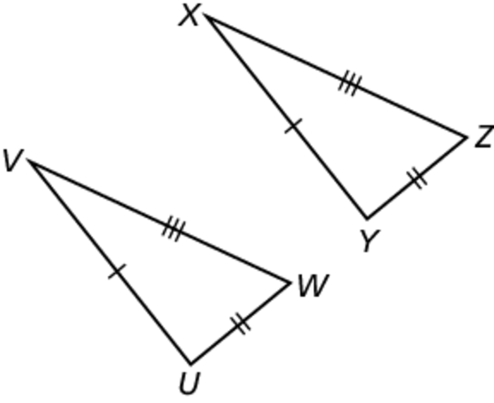

5. Determine whether the figure is stable. Explain your reasoning.

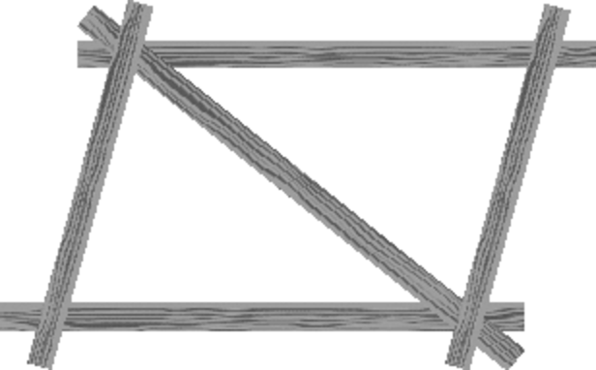

Name Date

5.5

Notetaking with Vocabulary **(continued)**

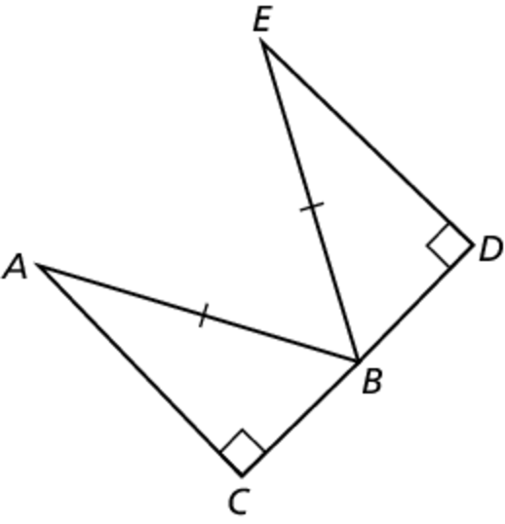 6. Redraw the triangles so they are side by side with corresponding   
parts in the same position. Then write a proof.

Given *B* is the midpoint of   
  and  are right angles.

Prove 

|  |  |
| --- | --- |
| STATEMENTS | REASONS |
| 1. | 1. Given |
| 2.  3. | 1. Definition of a midpoint 2. Definition of a right triangle |
| 4. | 1. HL congruence theorem (Theorem 5.9) |
|  |  |

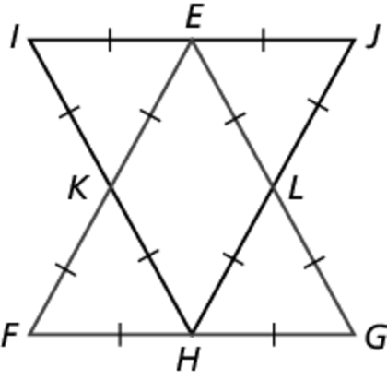 7. Write a proof.

Given   
 

Prove 

|  |  |
| --- | --- |
| STATEMENTS | REASONS |
|  | 1. Given 2. Segment addition postulate (Post. 1.2) 3. Substitution property of equality |
|  | 1. Transitive property of congruence (2.1) |
|  |  |
|  | 1. SSS congruence theorem (Theorem 5.8) |