Name Date

Notetaking with Vocabulary

For use after Lesson 5.4

5.4

In your own words, write the meaning of each vocabulary term.

legs – two congruent sides of an isosceles triangle

vertex angle – angle formed by the legs

base – third side of an isosceles triangle

base angles – two angles adjacent to the base of an isosceles triangle

Theorems

Theorem 5.6 Base Angles Theorem

If two sides of a triangle are congruent, then the angles opposite 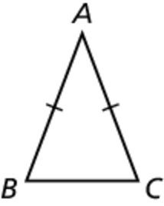  
them are congruent.

If  then 

Theorem 5.7 Converse of the Base Angles Theorem

If two angles of a triangle are congruent, then the sides opposite 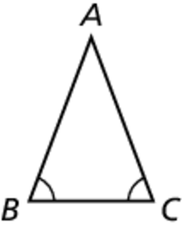  
them are congruent.

If  then 

Notes:

Name Date

5.4

Notetaking with Vocabulary **(continued)**

Corollaries

Corollary 5.2 Corollary to the Base Angles Theorem

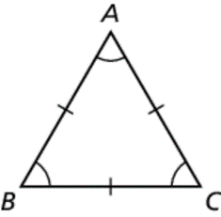If a triangle is equilateral, then it is equiangular.

Corollary 5.3 Corollary to the Converse of the Base   
 Angles Theorem

If a triangle is equiangular, then it is equilateral.

Notes:

Extra Practice

In Exercises 1–4, complete the statement. State which theorem you used.

1. If then 

2. If then 

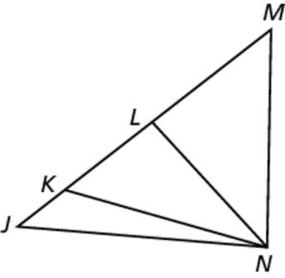

3. If then 

4. If then 

Name Date

5.4

Notetaking with Vocabulary **(continued)**

In Exercises 5 and 6, find the value of *x*.

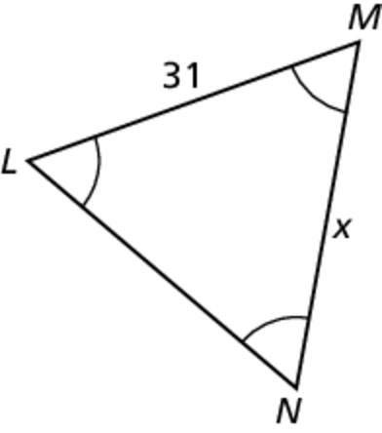 5.

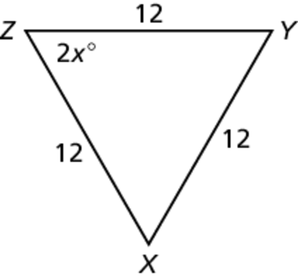 6.

In Exercises 7 and 8, find the values of *x* and *y*.

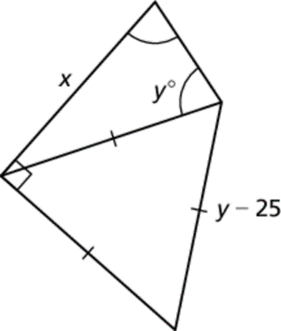 7.

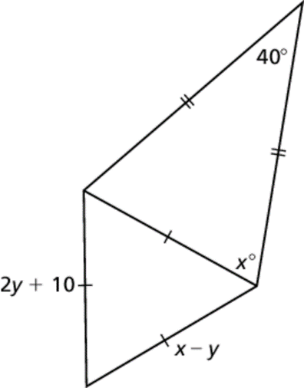 8.