Name Date

Notetaking with Vocabulary

For use after Lesson 5.3

5.3

In your own words, write the meaning of each vocabulary term.

congruent figures – geometric figures that have the same size and shape

rigid motion – transformation that preserves length and angle measure

Theorems

Theorem 5.5 Side-Angle-Side (SAS) Congruence Theorem

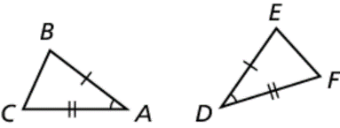If two sides and the included angle of one triangle are congruent to   
two sides and the included angle of a second triangle, then the two   
triangles are congruent.

If and then 

Notes:

Name Date

5.3

Notetaking with Vocabulary **(continued)**

Extra Practice

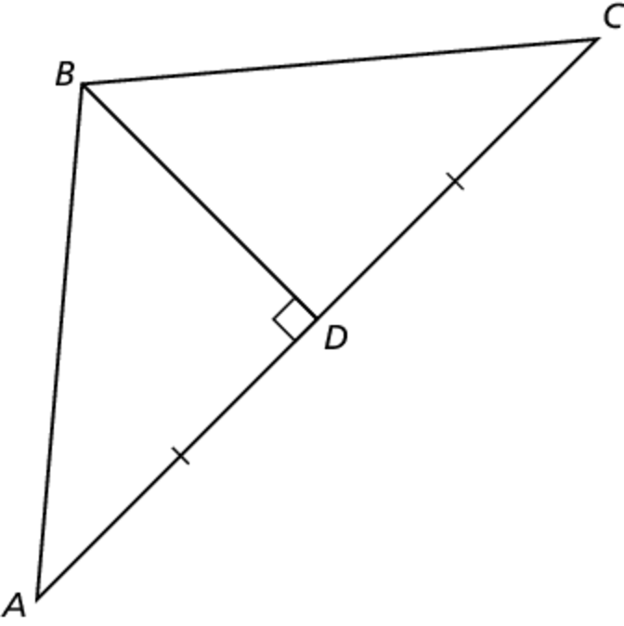In Exercises 1 and 2, write a proof.

1. **Given** 

**Prove** 

|  |  |
| --- | --- |
| **STATEMENTS** | **REASONS** |
|  | 1. Given |
|  | 1. Linear pair perpendicular theorem (3.10) |
|  | 1. Reflexive property of congruence (2.1) |
|  | 1. SAS congruence theorem (5.5) |
|  |  |

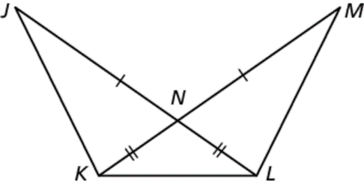 2. **Given** 

**Prove** 

|  |  |
| --- | --- |
| **STATEMENTS** | **REASONS** |
|  | 1. Given |
|  | 1. Vertical angles congruence theorem (2.6) |
|  | 1. SAS congruence theorem (5.5) |
|  |  |
|  |  |

Name Date

5.3

Notetaking with Vocabulary **(continued)**

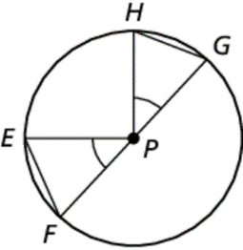**In Exercises 3 and 4, use the given information to name two   
triangles that are congruent. Explain your reasoning.**

3. ** and *P* is the center of the circle.

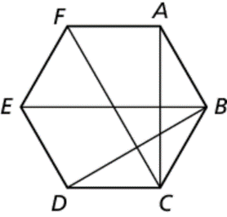 4. *ABCDEF* is a regular hexagon.

5. A quilt is made of triangles. You know   
and  Use the SAS Congruence  
Theorem (Theorem 5.5) to show that   


