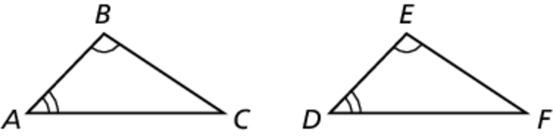Name Date

Notetaking with Vocabulary

For use after Lesson 5.2

5.2

In your own words, write the meaning of each vocabulary term.

corresponding parts – each part of a figure matched to its same part of its image after a rigid transformation

Theorems

Theorem 5.3 Properties of Triangle Congruence

Triangle congruence is reflexive, symmetric, and transitive.

**Reflexive** For any triangle 

**Symmetric** If then 

**Transitive** If and then 

Notes:

Theorem 5.4 Third Angles Theorem

If two angles of one triangle are congruent to two angles of  
another triangle, then the third angles are also congruent.

Notes:



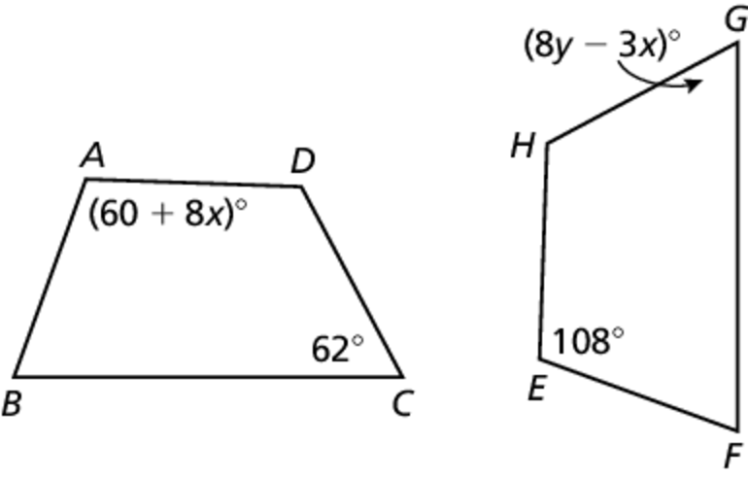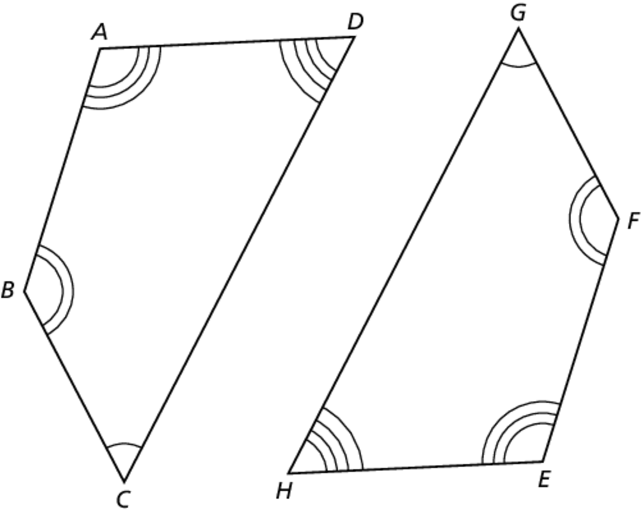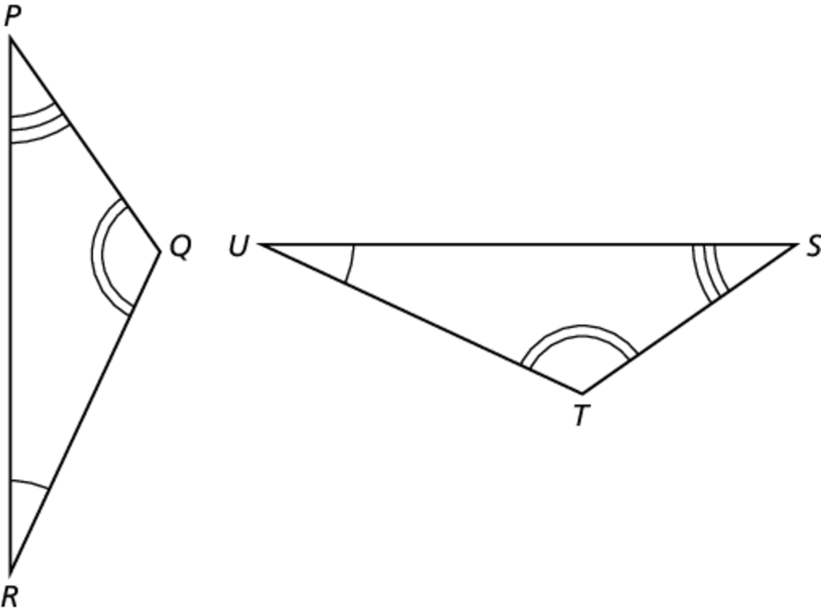Name Date

5.2

Notetaking with Vocabulary **(continued)**

**Extra Practice**

In Exercises 1 and 2, identify all pairs of congruent corresponding parts. Then write another congruence statement for the polygons.

1.  2. 

In Exercises 3 and 4, find the values of *x* and *y*.

3.  4. 

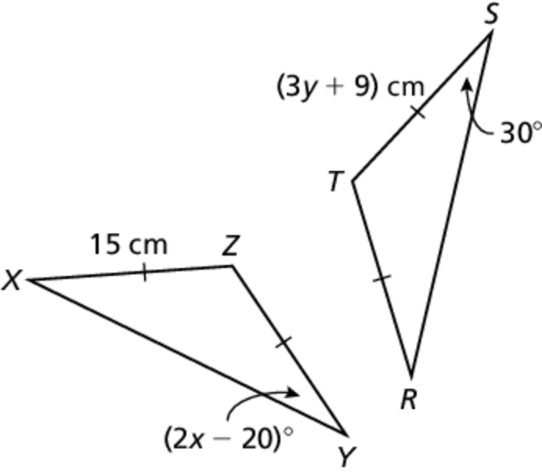

Name Date

5.2

Notetaking with Vocabulary **(continued)**

**In Exercises 5 and 6, show that the polygons are congruent. Explain your reasoning.**

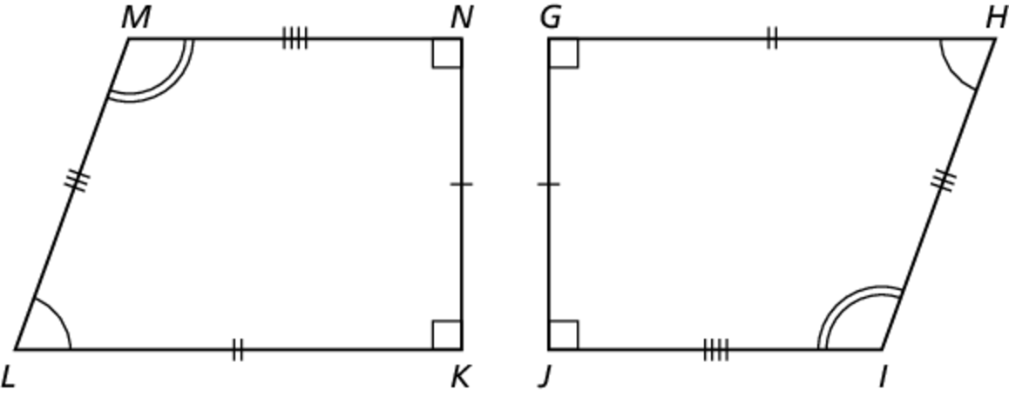 5. 6.

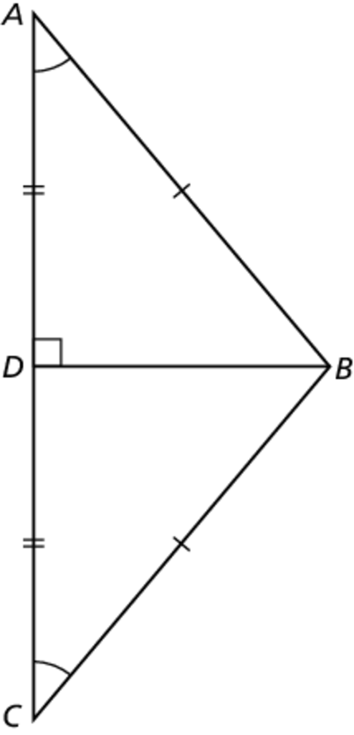

**In Exercises 7 and 8, find** 

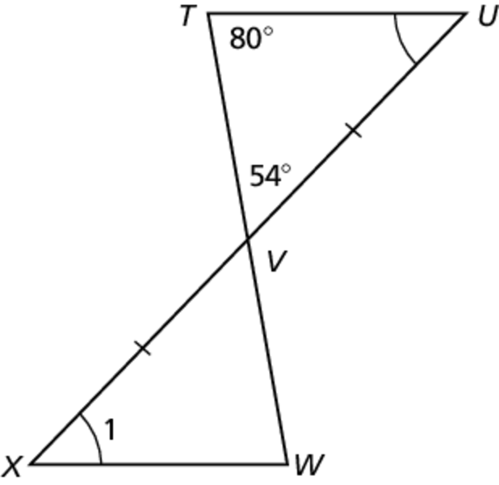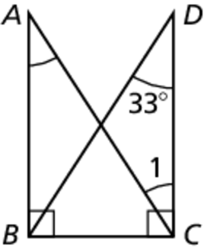 7. 8.