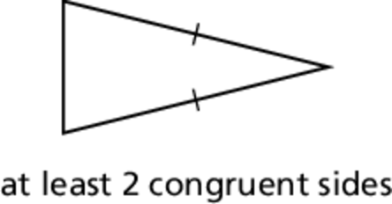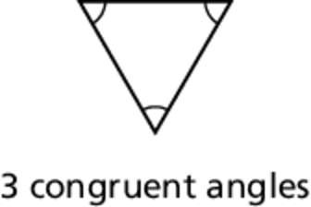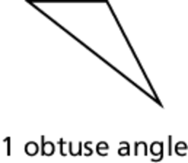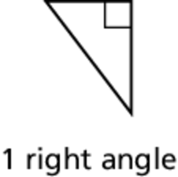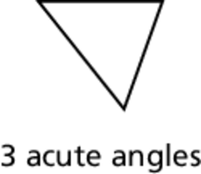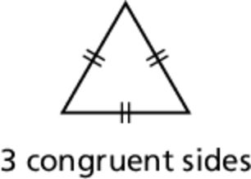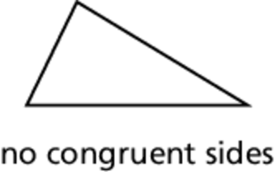Name Date

Notetaking with Vocabulary

For use after Lesson 5.1

5.1

In your own words, write the meaning of each vocabulary term.

interior angles – original angles inside a polygon

exterior angles – form linear pairs with the interior angles when the sides of a polygon are extended

corollary to a theorem – statement that can be proved easily using the theorem

Core Concepts

Classifying Triangles by Sides

|  |  |  |
| --- | --- | --- |
| **Scalene Triangle** | **Isosceles Triangle** | **Equilateral Triangle** |
|  |  |  |

Classifying Triangles by Angles

|  |  |  |  |
| --- | --- | --- | --- |
| **Acute Triangle** | **Right Triangle** | **Obtuse Triangle** | **Equiangular Triangle** |
|  |  |  |  |

Notes:

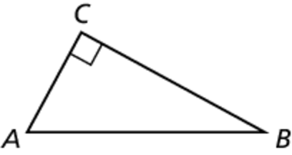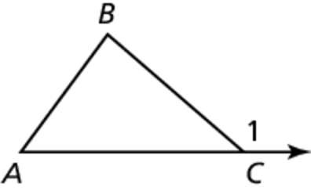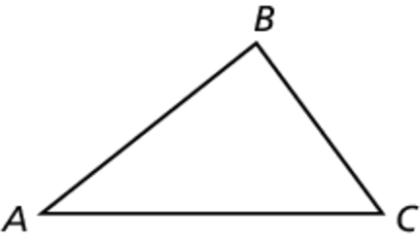Name Date

5.1

Notetaking with Vocabulary **(continued)**

Theorems

Theorem 5.1 Triangle Sum Theorem

The sum of the measures of the interior angles of a triangle is 180°.

Notes:



Theorem 5.2 Exterior Angle Theorem

The measure of an exterior angle of a triangle is equal to the sum of the  
measures of the two nonadjacent interior angles.

Notes:



Corollary 5.1 Corollary to the Triangle Sum Theorem

The acute angles of a right triangle are complementary.

Notes:



Name Date

5.1

Notetaking with Vocabulary **(continued)**

Extra Practice

In Exercises 1–3, classify the triangle by its sides and by measuring its angles.

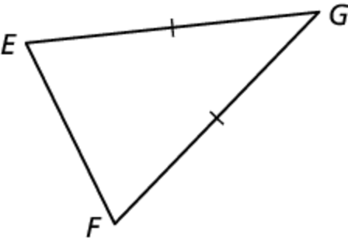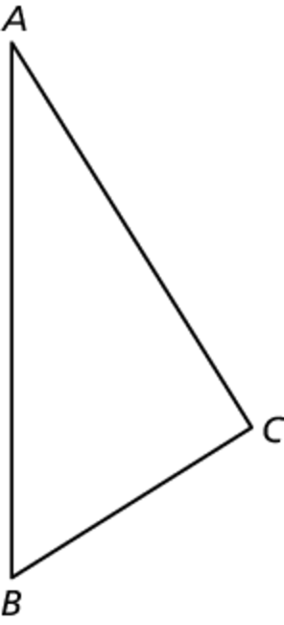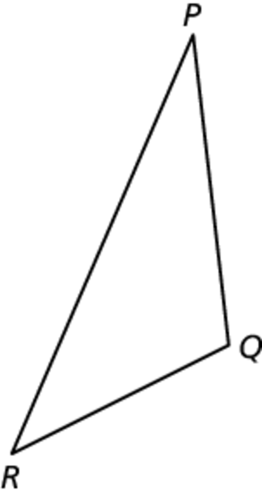 1. 2. 3.

4. Classify  by its sides. Then determine whether it is a right triangle.

*A*(6, 6), *B*(9, 3), *C*(2, 2)

**In Exercises 5 and 6, find the measure of the exterior angle.**

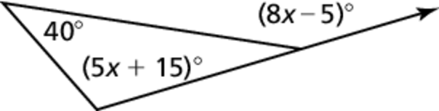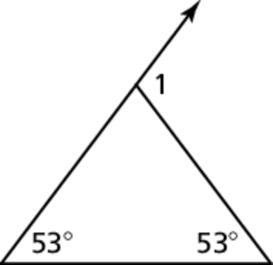 5. 6.

7. In a right triangle, the measure of one acute angle is twice the sum of the measure of   
the other acute angle and 30. Find the measure of each acute angle in the right triangle.