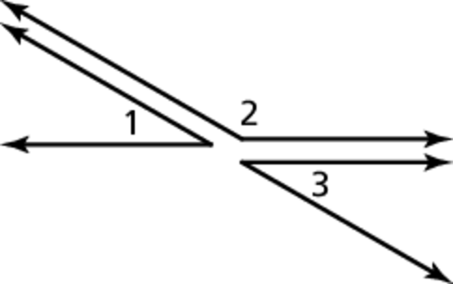Name Date

Notetaking with Vocabulary

For use after Lesson 2.6

2.6

In your own words, write the meaning of each vocabulary term.

flowchart proof, or flow proof

paragraph proof

Theorems and Postulates

Theorem 2.3 Right Angles Congruence Theorem

All right angles are congruent.

Notes:

Theorem 2.4 Congruent Supplements Theorem

If two angles are supplementary to the same angle (or to congruent angles), then they are congruent.

If  are supplementary and  are supplementary,   
then 

Notes:

Name Date

2.4

Notetaking with Vocabulary **(continued)**

Theorem 2.5 Congruent Complements Theorem

2.6

Notetaking with Vocabulary (continued)

If two angles are complementary to the same angle (or to congruent   
angles), then they are congruent.

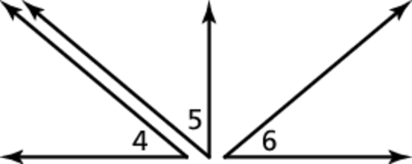If  are complementary and  are complementary,   
then 

Notes:

Postulate 2.8 Linear Pair Postulate

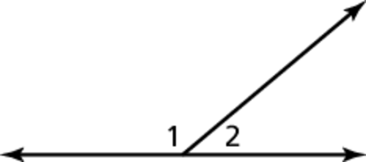If two angles form a linear pair, then they are supplementary.

 form a linear pair, so  are supplementary   
and 

Notes:

Theorem 2.6 Vertical Angles Congruence Theorem

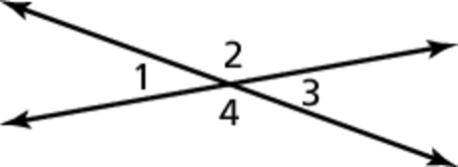Vertical angles are congruent.

Notes:



Name Date

2.6

Notetaking with Vocabulary **(continued)**

Extra Practice

1. Complete the flowchart proof. Then write a two-column proof. TA: K:\BI-HighSchool\Geometry.01\Ancillaries\Production\Geometry SJ\art\ch 02\HSGeo_sj_0206_006.eps,4/8/2014 10:21:41 AM

**Given** **

**

**Prove** 

Subtraction Property of Equality







Transitive Property of Equality

Definition of supplementary angles



Definition of supplementary angles



Definition of congruent angles

Given

Given

Two-Column Proof

|  |  |
| --- | --- |
| **STATEMENTS** | **REASONS** |
|  | 1. Given 2. Definition of supplementary angles 3. Transitive property of equality |
|  |  |
|  |  |
|  |  |
|  |  |
|  |  |
|  |  |
|  |  |
|  |  |