Name Date

Notetaking with Vocabulary

For use after Lesson 10.2

10.2

In your own words, write the meaning of each vocabulary term.

central angle – angle whose vertex is the center of the circle

minor arc – points on a circle which make up an angle less than 180⁰

major arc – points on a circle that do not lie on the minor arc

semicircle – an arc with endpoints that are the endpoints of a diameter

measure of a minor arc – measure of its central angle

measure of a major arc – difference of 360⁰ and the measure of the related minor arc

adjacent arcs – two arcs of the same circle that intersect at exactly one point

congruent circles – two circles in which a rigid motion or a composition of rigid motions maps one circle onto the other

congruent arcs – two arcs that have the same measure and they are arcs of the same circle or of congruent circles

similar arcs – two arcs that have the same measure

Core Concepts

Measuring Arcs

The **measure of a minor arc** is the measure of its central angle. The 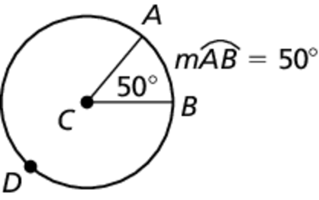expression is read as “the measure of arc *AB*.”

The measure of the entire circle is 360°. The **measure of a major arc** is the difference of 360° and the measure of the related minor arc. The measure of a semicircle is 180°. 

Notes:

Name Date

10.2

Notetaking with Vocabulary **(continued)**

Postulates

Postulate 10.1 Arc Addition Postulate

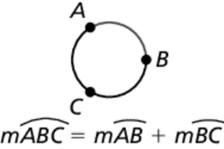The measure of an arc formed by two adjacent arcs is the sum of the measures of the two arcs.

Notes:

Theorems

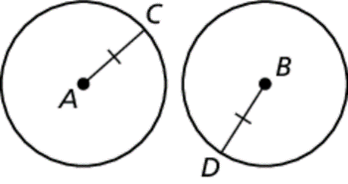Theorem 10.3 Congruent Circles Theorem

Two circles are congruent circles if and only if they have the same radius.

Notes:



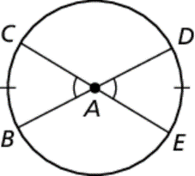Theorem 10.4 Congruent Central Angles Theorem

In the same circle, or in congruent circles, two minor arcs are congruent if and only if their corresponding central angles are congruent.

Notes:



Theorem 10.5 Similar Circles Theorem

All circles are similar.

Notes:

Name Date

10.2

Notetaking with Vocabulary **(continued)**

Extra Practice

In Exercises 1–8, identify the given arc as a *major arc*, *minor arc*, or *semicircle*. Then find the measure of the arc.

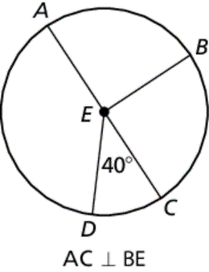 1.  2. 

3.  4. 

5.  6. 

7.  8. 

9. Inabove, tell whether  Explain why or why not.

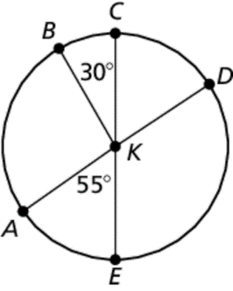 **10.** Infind the measure of 

11. Find the value of *x*. Then find the measure of

