Heating Curve Worksheet Name: Date:

The diagram below is a plot of temperature vs. time. It represents the heating of what is initially ice at -10ºC at a near constant rate of heat transfer.

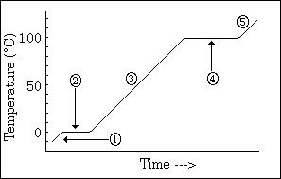

- What phase or phases are present during segment (2)

  - What phase change, if any, is taking place?

- What phase or phases are present during segment (3)

  - What phase change, if any, is taking place?

- What is the melting point of this substance?

- At what temperature would this sample finish boiling?

- The heat of fusion for water (H_{f}) is 6.009 kJ/mole and the heat of vaporization (H_{v}) for water is 40.79kJ/mole.

a) How much energy would be required to melt 50.0 grams of ice at 0ºC to water at 0ºC?

b) How much energy would be required to convert 2.0 moles of water at 100ºC to water vapor at 100ºC?

Phase Diagram Worksheet Name: _________________

Refer to the phase diagram below when answering the following questions.

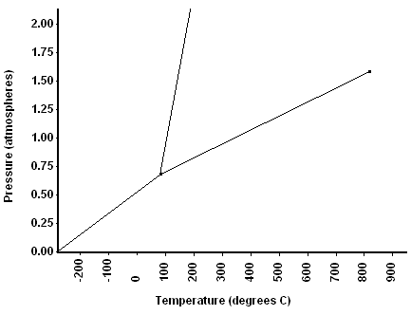

1) What are the values for temperature and pressure at STP? T= ________, P= ________
2) What is the normal freezing point of this substance? ________
3) What is the normal boiling point of this substance? ________
4) What is the condition of the triple point of this substance? T= ________, P= _______
5) If a quantity of this substance was at an initial pressure of 1.25 atm and a temperature of 300⁰ C was lowered to a pressure of 0.25 atm, what phase transition(s) would occur? ____________
6) If a quantity of this substance was at an initial pressure of 1.25 atm and a temperature of 0⁰ C was lowered to a pressure of 0.25 atm, what phase transition(s) would occur? ____________
7) If a quantity of this substance was at an initial pressure of 1.0 atm and a temperature of 200⁰ C was lowered to a temperature of -200⁰ C, what phase transition(s) would occur? ____________
8) At what temperature do the gas and liquid phases become indistinguishable at 1.25 atm? ______
9) At what pressure would it be possible to find this substance in the gas, liquid, and solid phase? _____

