Acid-Base Neutralization Lab

Purpose:
- Test the pH of an acid and a base.
- Perform a neutralization reaction.
- Perform dehydration of a salt.
- Conduct a flame test to determine the salts produced.

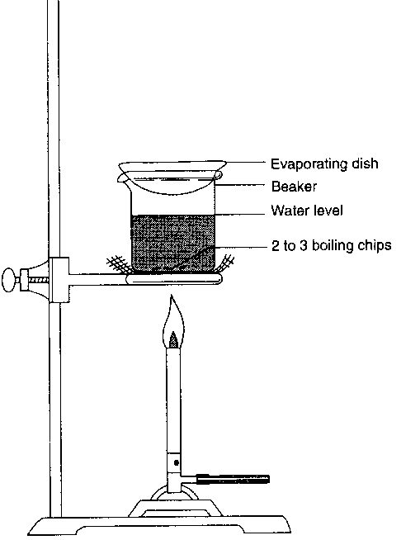
Materials:
- M sodium hydroxide solution (NaOH)
- M hydrochloric acid solution (HCl)
0.1 M silver nitrate solution
pH paper
pipet
Test tube
glass stirring rod
ring stand
bunsen burner and hose
striker
wire gauze
evaporating dish
tongs
spatula
rinse bottle with distilled water

Procedure Part A:
- Goggles must be worn at all times during the lab!!!
- Use a pipet to place a drop or two of sodium hydroxide (NaOH) onto the pH paper. Record your results.
- Put 2.0 mL of 1.0 M sodium hydroxide solution (NaOH) into the test tube.
- Use a pipet to place a drop or two of hydrochloric acid (HCl) onto the pH paper. Record your results.
- Add 2.0 mL of 1.0 M hydrochloric acid solution (HCl) into the test tube.
- Use the glass stirring rod to completely mix the acid and base in the solution.
- If needed you can use a pipet to squeeze and blow bubbles into the solution repeatedly to completely mix the acid and base.
- Pour the resulting solution into a clean evaporating dish and place on the ring stand over the wire gauze.
- Evaporate to dryness by heating over a Bunsen burner.
- While the product is heating, thoroughly clean and dry the test tube.
- When evaporation is complete, note and record the appearance of the salt, and divide it into two equal portions.
- Dissolve one portion in 20 drops of distilled water in a clean test tube.
- Use pH paper to test the pH of this solution. Record your results.
- Test the dissolved sample for chlorine ions by adding 2 drops of 0.1 M silver nitrate solution. A distinct clouding of the solution or the formation and settling of a white solid indicates the presence of Cl⁻. Record the test results.
- Moisten the end of a clean glass stirring rod with distilled water.
- Dip the moist end of the rod into the second portion of collected solid so that solid particles adhere to the rod.
- Place the end of the rod with adhering solid into the flame of your burner. The appearance of a bright orange-yellow flame confirms the presence of sodium ions. Record the results of this flame test.
- Appropriately discard your solution and remaining salt.
- Thoroughly wash and dry all equipment.

Analysis Questions:
- Explain the pH scale and how it is used. What range refers to acids? What range refers to bases? What value is neutral?

- Identify the pH of each solution used during your experiment; hydrochloric acid, sodium hydroxide, and the final salt solution.

- All neutralization reactions will produce what two products? Explain your answer.

- What product, specifically, is left in the evaporating dish? How do you know this?

- Write the complete balanced equation for the neutralization reaction that took place during this experiment.

- What is a flame test? What is the significance of conducting a flame test in the final step in this lab?

