Name Date

Notetaking with Vocabulary

For use after Lesson 7.1

7.1

In your own words, write the meaning of each vocabulary term.

diagonal – segment that joins two nonconsecutive vertices of a polygon

equilateral polygon – polygon with all congruent sides

equiangular polygon – polygon with all interior angles congruent

regular polygon – convex polygon that is both equilateral and equiangular

Theorems

Theorem 7.1 Polygon Interior Angles Theorem

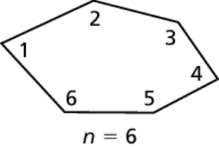The sum of the measures of the interior angles   
of a convex *n-*gon is 



Notes:

Name Date

7.1

Notetaking with Vocabulary **(continued)**

Corollary 7.1 Corollary to the Polygon Interior Angles Theorem

The sum of the measures of the interior angles of a quadrilateral is 

Notes:

Theorem 7.2 Polygon Exterior Angles Theorem

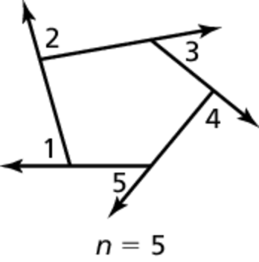The sum of the measures of the exterior angles of a  
convex polygon, one angle at each vertex, is 



Notes:

Name Date

7.1

Notetaking with Vocabulary **(continued)**

Extra Practice

In Exercises 1–3, find the sum of the measures of the interior angles of the indicated convex polygon.

1. octagon 2. 15-gon 3. 24-gon

In Exercises 4–6, the sum of the measures of the interior angles of a convex polygon is given. Classify the polygon by the number of sides.

4.  5.  6. 

In Exercises 7–10, find the value of *x*.

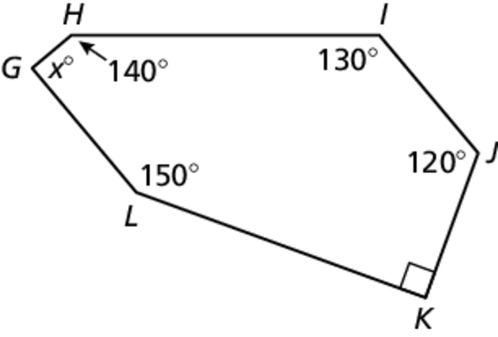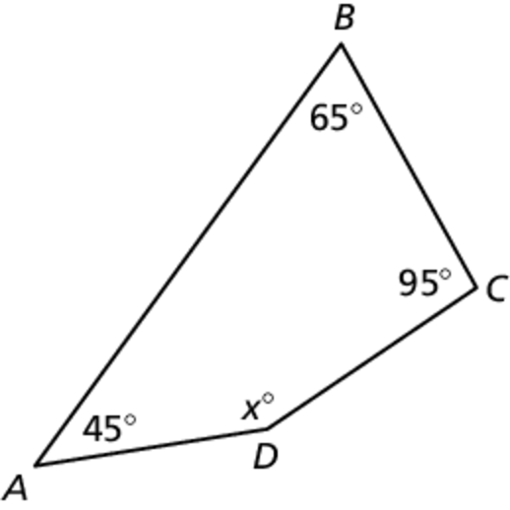 7. 8.

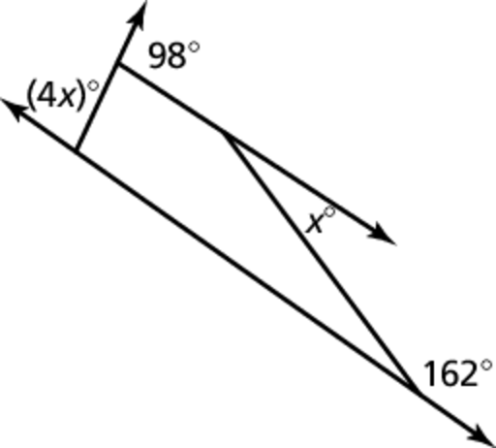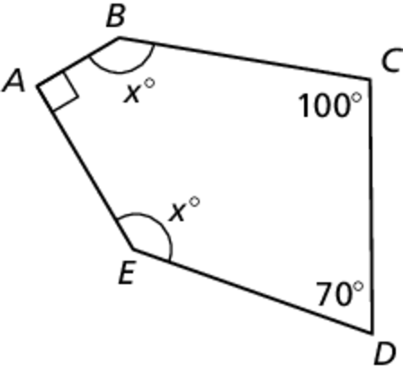 9. 10.