Name Date

Notetaking with Vocabulary

For use after Lesson 5.8

5.8

In your own words, write the meaning of each vocabulary term.

coordinate proof – involves placing geometric figures in a coordinate plane

Notes:

Name Date

5.8

Notetaking with Vocabulary **(continued)**

Extra Practice

In Exercises 1 and 2, place the figure in a coordinate plane in a convenient way. Assign coordinates to each vertex. Explain the advantages of your placement.

|  |  |
| --- | --- |
| 1. an obtuse triangle with height of 3 units  and base of 2 units | 2. a rectangle with length of 2*w* |
| TA: D:\Mac Art\geomatry-5-art\ch05\HSGeo_t_0508_003.eps,27/May/2014 12:32:10 replaced: 6/29/2018 3:44:05 PM | TA: D:\Mac Art\geomatry-5-art\ch05\HSGeo_t_0508_003.eps,27/May/2014 12:32:10 replaced: 6/29/2018 3:44:06 PM |

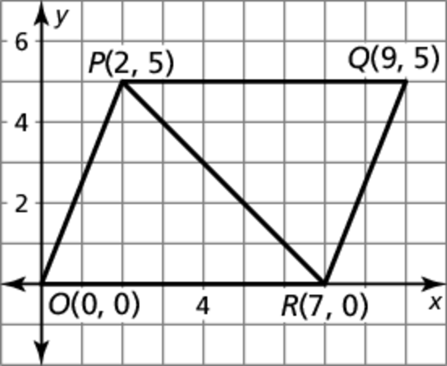In Exercises 3 and 4, write a plan for the proof.

3. **Given** Coordinates of vertices of  and 

**Proof** 

Name Date

5.8

Notetaking with Vocabulary **(continued)**

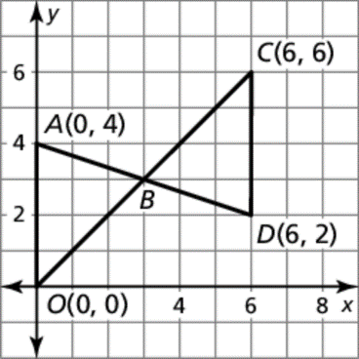 4. **Given** Coordinates of vertices of and 

**Prove** *B* is the midpoint of  and 

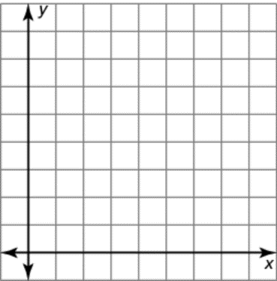 5. Graph the triangle with vertices *A*(0, 0), *B*(3*m*, *m*), and   
*C*(0, 3*m*). Find the length and the slope of each side of the   
triangle. Then find the coordinates of the midpoint of each   
side. Is the triangle a right triangle? isosceles? Explain.   
(Assume all variables are positive.)

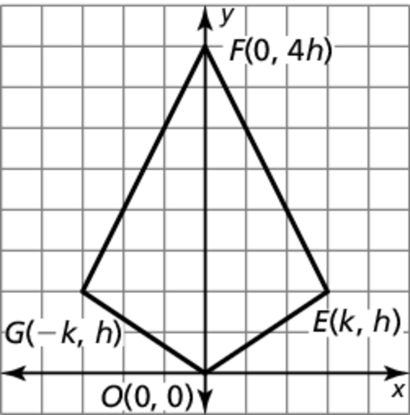

6. Write a coordinate proof.

**Given** Coordinates of vertices of  and 

**Prove** 