Acid-Base Neutralization Lab

Purpose
- Test the pH of an acid and a base.
- Perform a neutralization reaction.
- Perform dehydration of a salt.
- Conduct a flame test to determine the salts produced.

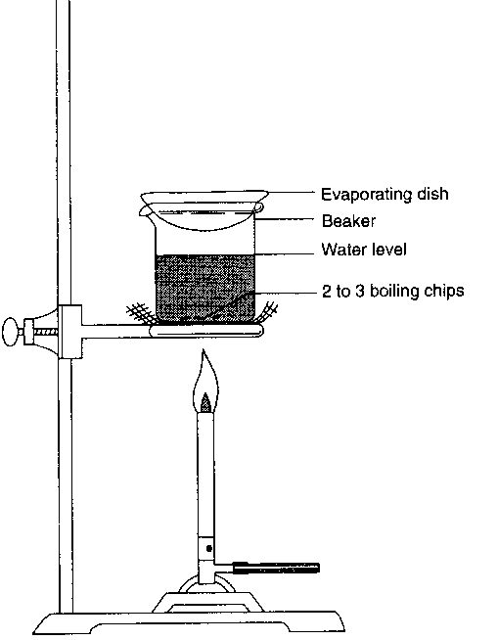
Materials
- M sodium hydroxide solution (NaOH)
- M hydrochloric acid solution (HCl)
0.1 M silver nitrate solution
pH paper
pipet
Test tube
glass stirring rod
ring stand
bunsen burner and hose
striker
wire gauze
evaporating dish
tongs
spatula
rinse bottle with distilled water

Procedure
- Goggles must be worn at all times during the lab!!!
- Use a pipet to place a drop of sodium hydroxide (NaOH) onto the pH paper. Record your results. Include both color of paper and pH value.
- Put 2.0 mL of 1.0 M sodium hydroxide solution (NaOH) into the test tube.
- Use a pipet to place a drop of hydrochloric acid (HCl) onto the pH paper. Record your results. Include both color of paper and pH value.
- Add 2.0 mL of 1.0 M hydrochloric acid solution (HCl) into the test tube.
- Use the glass stirring rod to completely mix the acid and base in the solution.
- Pour the resulting solution into a clean evaporating dish and place on the ring stand over the wire gauze.
- Evaporate to dryness by heating over a Bunsen burner. Record all observations.
- While the product is heating, thoroughly clean and dry the test tube.
- When evaporation is complete, note and record the appearance of the salt, and divide it into two equal portions.
- Dissolve one portion in 20 drops of distilled water in a clean test tube.
- Use pH paper to test the pH of this solution. Record your results.
- Test the dissolved sample for chlorine ions by adding 2 drops of 0.1 M silver nitrate solution. A distinct clouding of the solution or the formation and settling of a white solid indicates the presence of Cl⁻. Record the test results.
- Moisten the end of a clean glass stirring rod with distilled water.
- Dip the moist end of the rod into the second portion of collected solid so that solid particles adhere to the rod.
- Place the end of the rod with adhering solid into the flame of your burner. The appearance of a bright orange-yellow flame confirms the presence of sodium ions. Record the results of this flame test.
- Appropriately discard your solution and remaining salt.
- Thoroughly wash and dry all equipment.
- Spray and wipe down all lab surfaces.

Data
- Record and label all data from the steps of your procedure.
- Write the complete balanced equation for the neutralization reaction that took place during this experiment.
- Identify at least three unique observations collected during the experiment.

Analysis
A well thought out evaluation of the data collected. Refer back to your procedure and the data collected during the experiment. Did you achieve the results expected? Is there anything that surprised you? Compare and contrast the pH of HCl, NaOH, and your product. Identify each as an acid, base, or neutral. What product is left in your evaporating dish after dehydration? Explain. Identify and explain the results to your flame test. Reflect upon the experiment and identify at least two possible errors that affected your results. Then provide suggestions for improvement in the future.

Analysis needs to be in essay format using complete sentences with appropriate grammar and punctuation. Do not repeat the steps from your procedure.

