Name Date

Notetaking with Vocabulary

For use after Lesson 2.3

2.3

In your own words, write the meaning of each vocabulary term.

line perpendicular to a plane

Postulates

Point, Line, and Plane Postulates

Postulate Example

2.1 Two Point Postulate Through points *A* and *B*, there is   
Through any two points, there 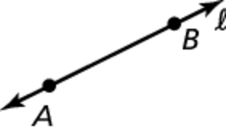 exactly one line . Line  contains  
exists exactly one line. at least two points.

2.2 Line-Point Postulate  
A line contains at least two points.

2.3 Line Intersection Postulate 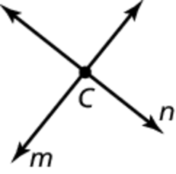 The intersection of line *m* and   
If two lines intersect, then their line *n* is point *C*.  
intersection is exactly one point.

2.4 Three Point Postulate 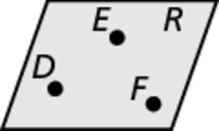 Through points *D*, *E*, and *F*, there is   
Through any three noncollinear exactly one plane, plane *R*. Plane *R*  
points, there exists exactly contains at least three noncollinear   
one plane. points.

2.5 Plane-Point Postulate   
A plane contains at least three   
noncollinear points

Notes:

Name Date

2.3

Notetaking with Vocabulary **(continued)**

Point, Line, and Plane Postulates (continued)

Postulate Example

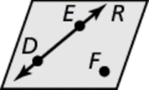2.6 Plane-Line Postulate Points *D* and *E* lie in plane *R*, so   
If two points lie in a plane, then  lies in plane *R*.  
the line containing them lies in   
the plane.

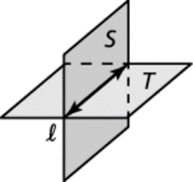2.7 Plane Intersection Postulate The intersection of plane *S* and  
If two planes intersect, then their plane *T* is line   
intersection is a line.

Notes:

Extra Practice

In Exercises 1 and 2, state the postulate illustrated by the diagram.

1.



If

then

2.



If

then

Name Date

2.3

Notetaking with Vocabulary **(continued)**

In Exercises 3–6, use the diagram to write an example of the postulate.

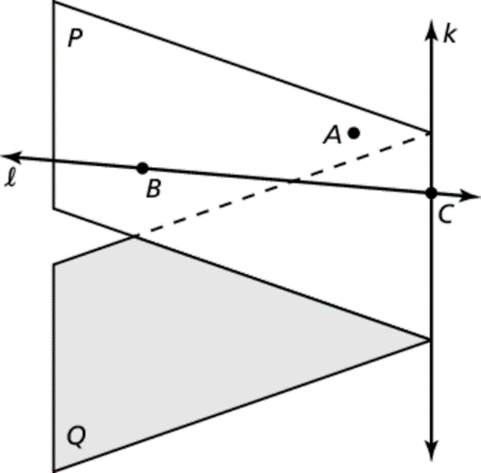 3. Two Point Postulate (Postulate 2.1)

4. Line-Point Postulate (Postulate 2.2)

5. Plane-Point Postulate (Postulate 2.5)

6. Plane Intersection Postulate (Postulate 2.7)

In Exercises 7 and 8, sketch a diagram of the description.

7. at point *R* 8.  in plane *U* intersecting at point *E*,   
 and point *C* not on plane *U*

In Exercises 9–14, use the diagram to determine whether you can assume the statement.

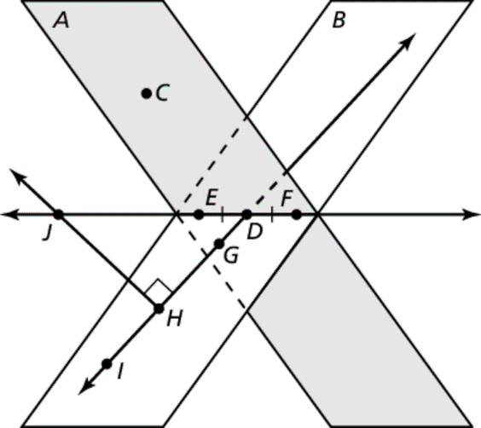 9. Planes *A* and *B* intersect at 

10. Points *C* and *D* are collinear.

11. 

12.  is a bisector of at point *D*.

13. 

14.  are complementary angles.