Name Date

Notetaking with Vocabulary

For use after Lesson 2.1

2.1

In your own words, write the meaning of each vocabulary term.

conditional statement – logical statement that has two parts, a hypothesis (*p*) and a conclusion (*q*)

if-then form – conditional statement where “if” part contains the hypothesis and “then” part contains the conclusion

hypothesis – “if” part of conditional statement

conclusion – “then” part of conditional statement

negation – opposite of the original statement

converse – exchange the hypothesis and conclusion

inverse – negate both the hypothesis and conclusion

contrapositive – first write the converse, then negate both the hypothesis and conclusion

equivalent statements – two statements that are either both true or both false

perpendicular lines – two lines that intersect to form a right angle

biconditional statement – when a conditional statement and its converse are both true, “if and only if”

truth value – when reading a statement it is either true (T) or false (F)

truth table – contains truth values for a statement and determines conditions under which the statement is true

Name Date

2.1

Notetaking with Vocabulary **(continued)**

Core Concepts

Conditional Statement

A **conditional statement** is a logical statement that has two parts, a *hypothesis p* and a *conclusion q*.   
When a conditional statement is written in **if-then form**, the “if” part contains the **hypothesis** and the  
 “then” part contains the **conclusion**.

Words If *p*, then *q*. Symbols (read as “*p* implies *q*”)

Notes: 1. All birds have feathers.

2. You are in Texas if you are in Houston.

Negation

The **negation** of a statement is the *opposite* of the original statement. To write the negation of a statement *p*,   
you write the symbol for negation before the letter. So, “not *p*” is written 

Words not *p* Symbols 

Notes: 1. The ball is red.

2. The cat is not black.

Related Conditionals

Consider the conditional statement below.

Words If *p*, then *q*. Symbols 

Converse To write the **converse** of a conditional statement, exchange the hypothesis   
 and the conclusion.

Words If *q*, then *p*. Symbols 

Inverse To write the **inverse** of a conditional statement, negate both the hypothesis   
 and the conclusion.

Words If not *p*, then not *q*. Symbols 

Name Date

2.1

Notetaking with Vocabulary **(continued)**

Related Conditionals **(continued)**

Contrapositive To write the **contrapositive** of a conditional statement, first write   
 the converse. Then negate both the hypothesis and the conclusion.

Words If not *q*, then not *p*. Symbols 

A conditional statement and its contrapositive are either both true or both false. Similarly, the  
converse and inverse of a conditional statement are either both true or both false. In general,   
when two statements are both true or both false, they are called **equivalent statements**.

Notes: *p* “you are a guitar player”

*q* “you are a musician”

Biconditional Statement

When a conditional statement and its converse are both true, you can write them as a single   
*biconditional statement*. A **biconditional statement** is a statement that contains the phrase   
“if and only if.”

Words *p* if and only if *q* Symbols 

Any definition can be written as a biconditional statement.

Notes:

Name Date

2.1

Notetaking with Vocabulary **(continued)**

Extra Practice

In Exercises 1 and 2, rewrite the conditional statement in if-then form.

1. 

2. The sum of the measures of interior angles of a triangle is 

3. Let *p* be “Quadrilateral *ABCD* is a rectangle” and let *q* be “the sum of the angle measures is   
Write the conditional statement  the inverse  and the contrapositive  Then decide whether each statement is true or false.

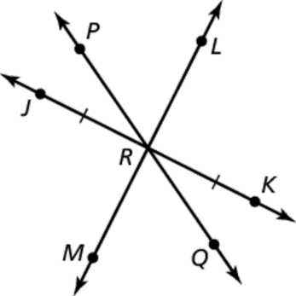In Exercises 4–6, decide whether the statement about the diagram is true.  
Explain your answer using the definitions you have learned.

4. 

5. 

6. 