Name Date

Notetaking with Vocabulary

For use after Lesson 10.1

10.1

In your own words, write the meaning of each vocabulary term.

circle – set of all points in a plane that are equidistant from a given point called the center of the circle

center – given point equidistant from all points on the circle

radius – segment whose endpoints are the center and any point on the circle

chord – segment whose endpoints are on a circle

diameter – chord that contains the center of the circle

secant – line that intersects a circle in two points

tangent – line in a plane of a circle that intersects the circle in exactly one point

point of tangency – point where the tangent intersects the circle

tangent circles – coplanar circles that intersect in one point

concentric circles – coplanar circles that have a common center

common tangent – line or segment that is tangent to two coplanar circles

Notes:

Name Date

10.1

Notetaking with Vocabulary **(continued)**

Core Concepts

Lines and Segments That Intersect Circles

A segment whose endpoints are the center and any point on a circle is a 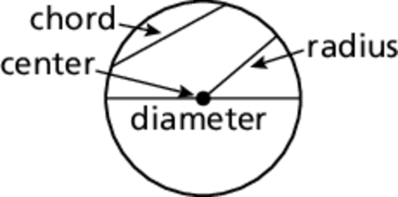**radius**.

A **chord** is a segment whose endpoints are on a circle. A **diameter** is a chord that contains the center of the circle.

A **secant** is a line that intersects a circle in two points.

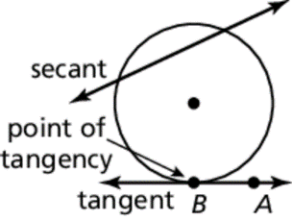A **tangent** is a line in the plane of a circle that intersects the circle in exactly one point, the **point of tangency**. The *tangent ray*and the *tangent segment*are also called tangents.

Notes:

Coplanar Circles and Common Tangents

In a plane, two circles can intersect in two points, one point, or no points. Coplanar circles that intersect in one point are called **tangent circles**. Coplanar circles that have a common center are called **concentric circles**.

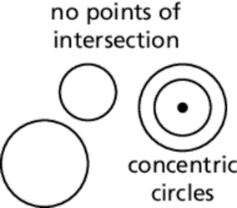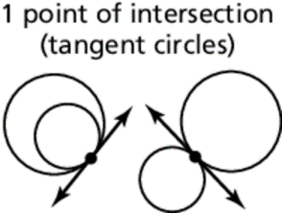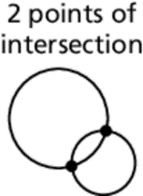

A line or segment that is tangent to two coplanar circles is called a common tangent. A *common internal tangent* intersects the segment that joins the centers of the two circles. A *common external tangent* does not intersect the segment that joins the centers of the two circles.

Notes:

Name Date

10.1

Notetaking with Vocabulary **(continued)**

Extra Practice

In Exercises 1–6, use the diagram.

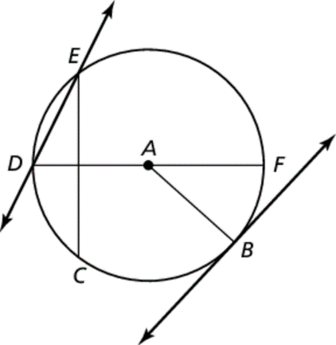 1. Name two radii. 2. Name a chord.

3. Name a diameter. 4. Name a secant.

5. Name a tangent. 6. Name a point of tangency.

In Exercises 7 and 8, use the diagram.

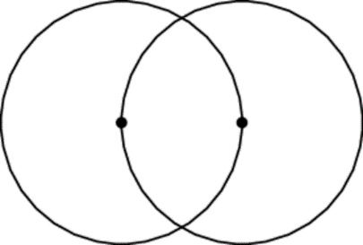 7. Tell how many common tangents the circles have and draw them.

8. Tell whether each common tangent identified in Exercise 7 is internal or external.

In Exercises 9 and 10, point *D* is a point of tangency.

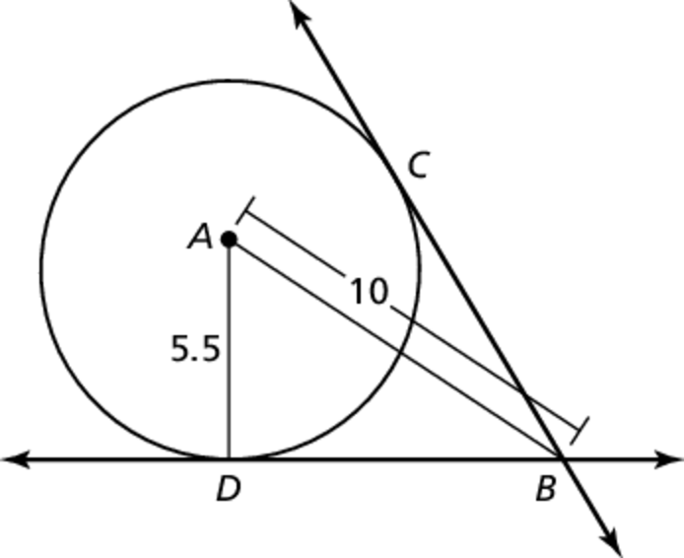 9. Find *BD*.

10. Point *C* is also a point of tangency. If find the value of *x* to the nearest tenth.